Client VM: IP: 10.0.2.7

Server VM: IP1: 10.0.2.9, IP2: 192.168.60.1

Host v: IP: 192.168.60.101

Task1: Network Setup

As for Server VM, two network adaptors are added, one has the IP address of 10.0.2.9, the other has the IP address of 192.168.60.1. It is because the server needs to be accessible by both client and the host v.

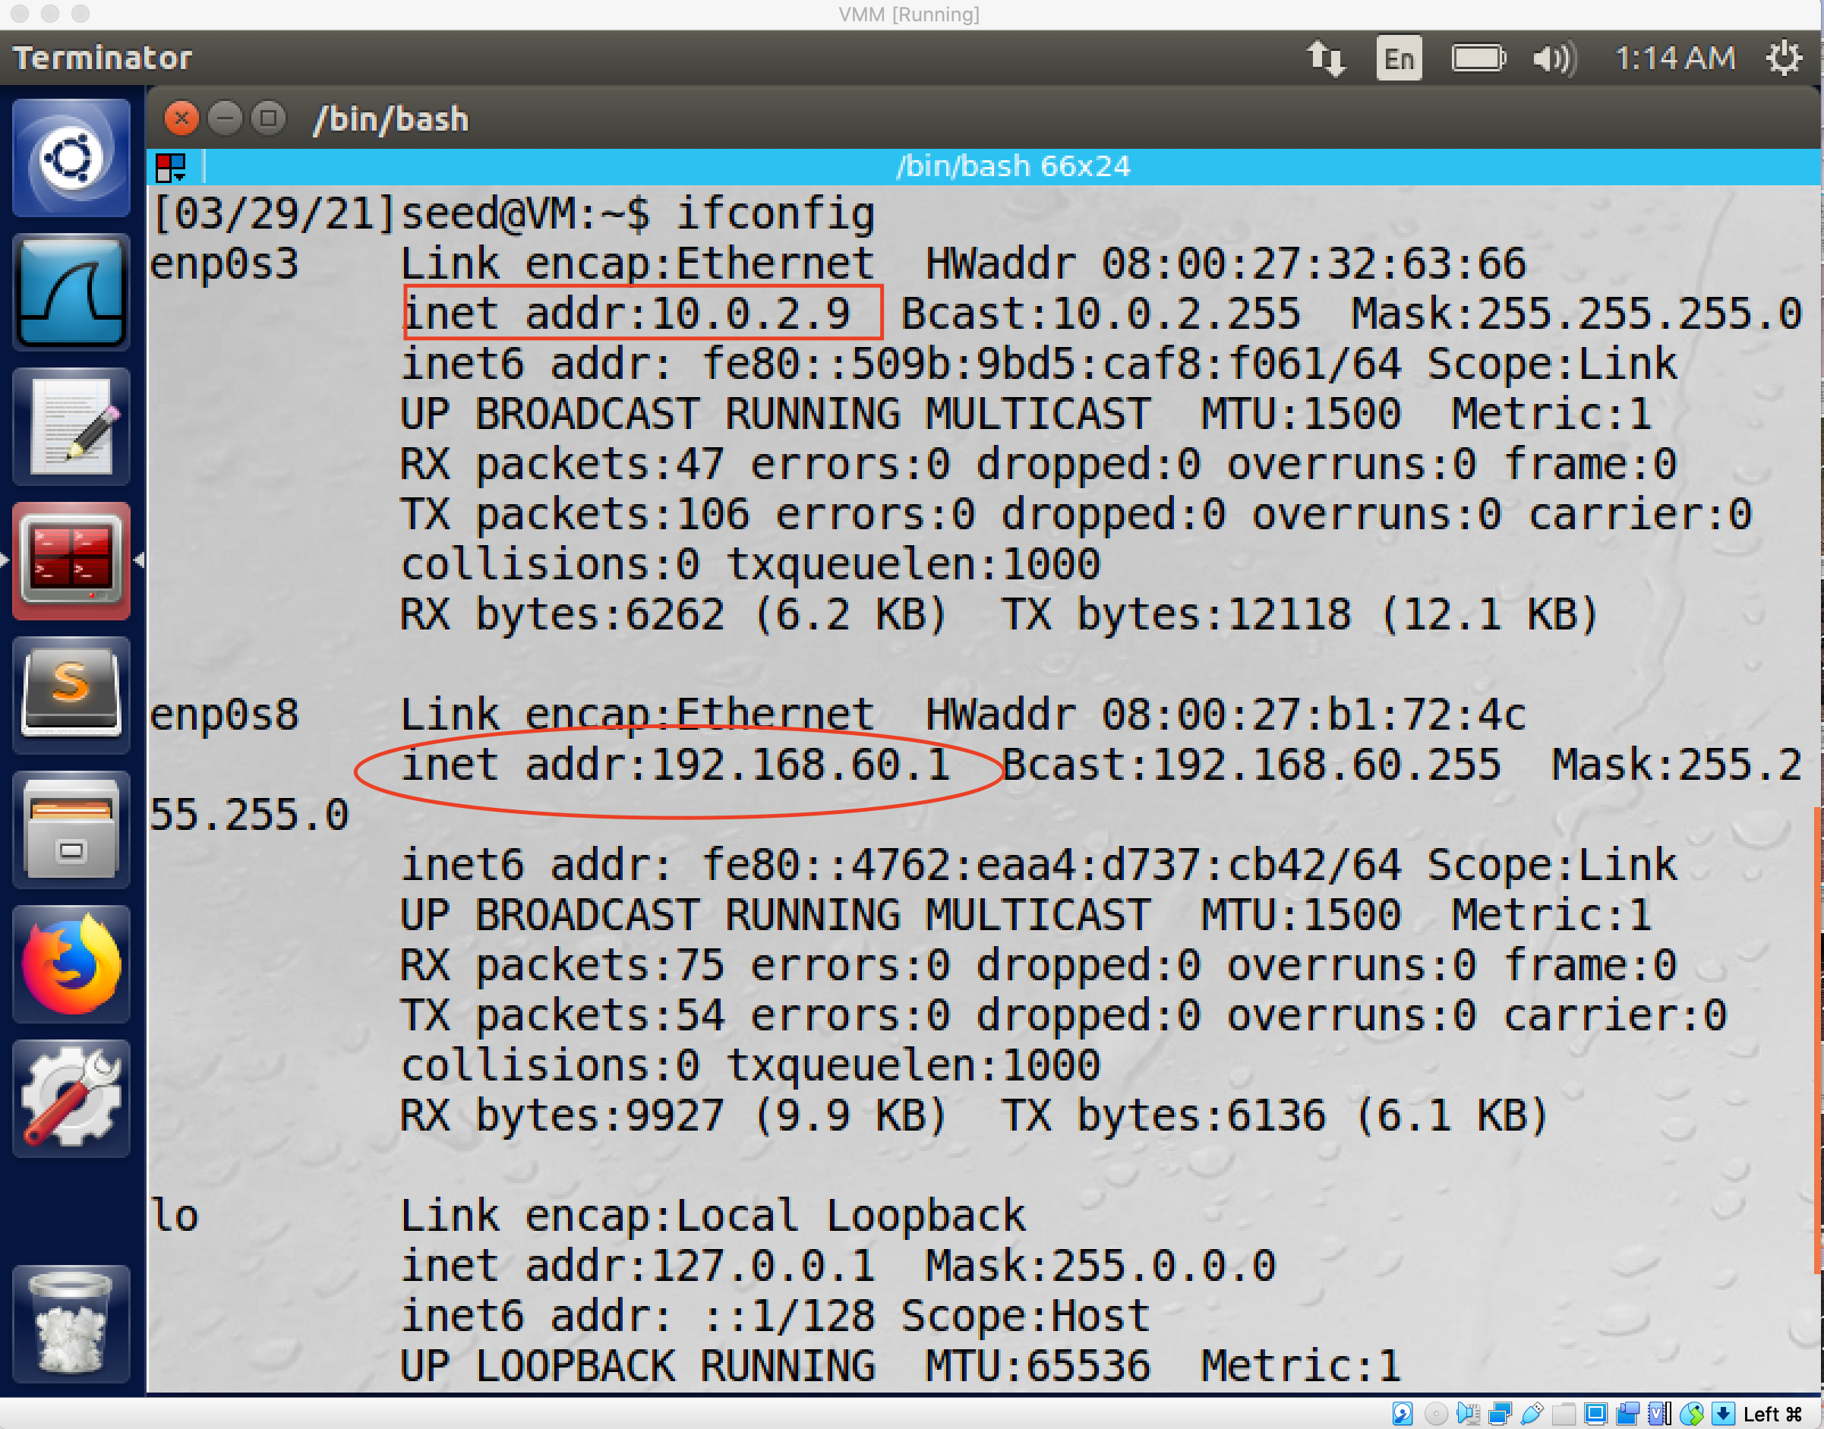

As for the host v, I create a new connection for it which set up the ipv4 address as 192.168.60.101 to make sure it within the same private network with the server, which means the client cannot access it.

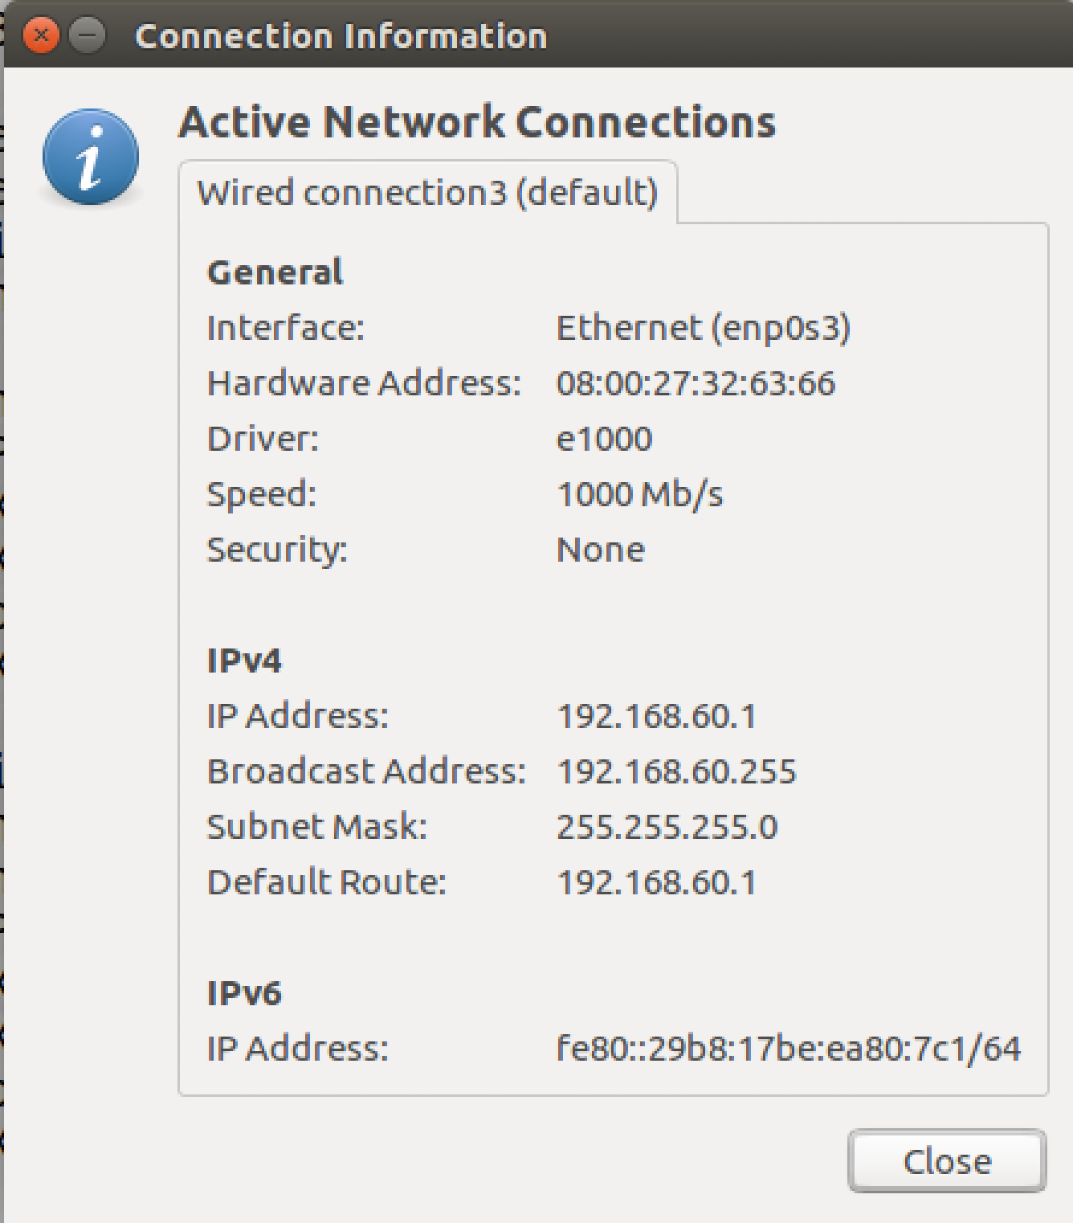

To test this setup, several tests have been done.

1. I ping the VPN server from the Host U.

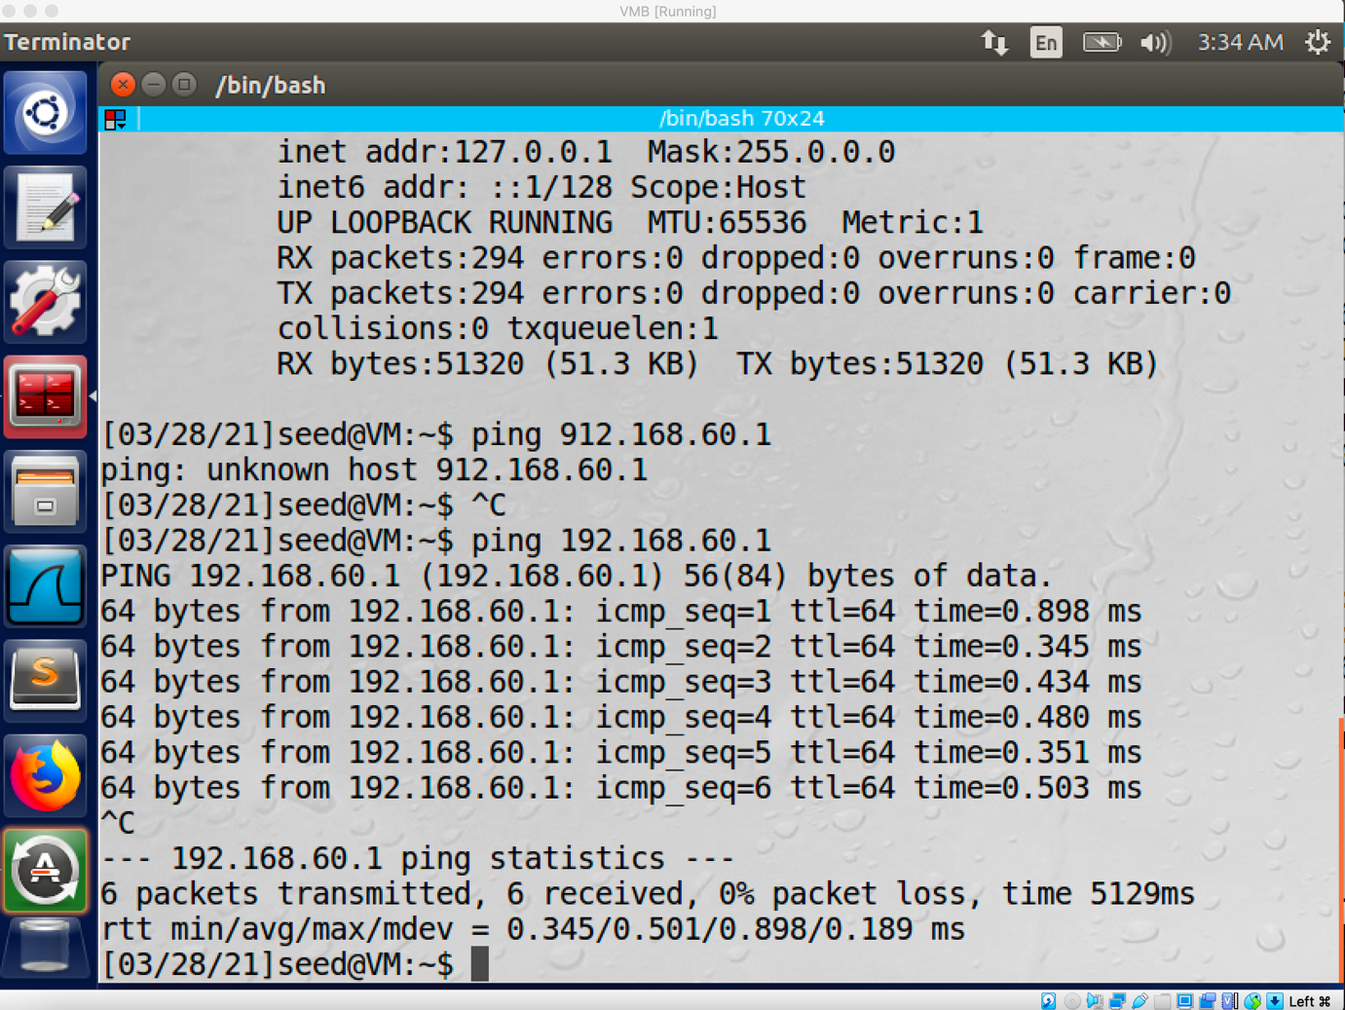

The ping operation is successful.

1. Ping host V from VPN server.

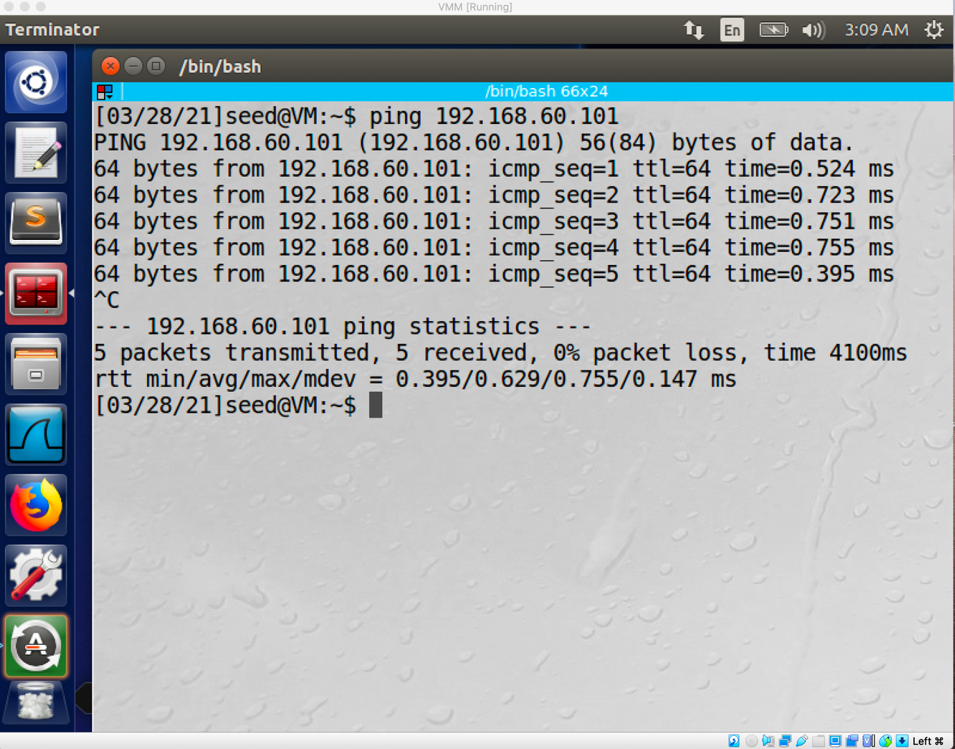

The ping operation is succeeded.

1. Ping host V from host U.

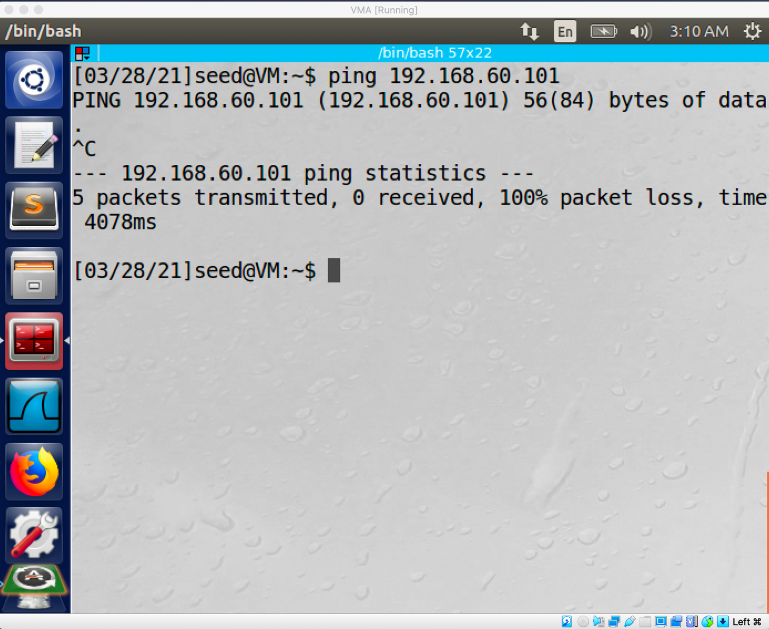

The ping operation is not successful.

Task2: Create and configure the TUN interface

1. Name of the interface:

Firstly, I create a python file to set up a tun interface, then I modified the name of the tun interface to my last name.

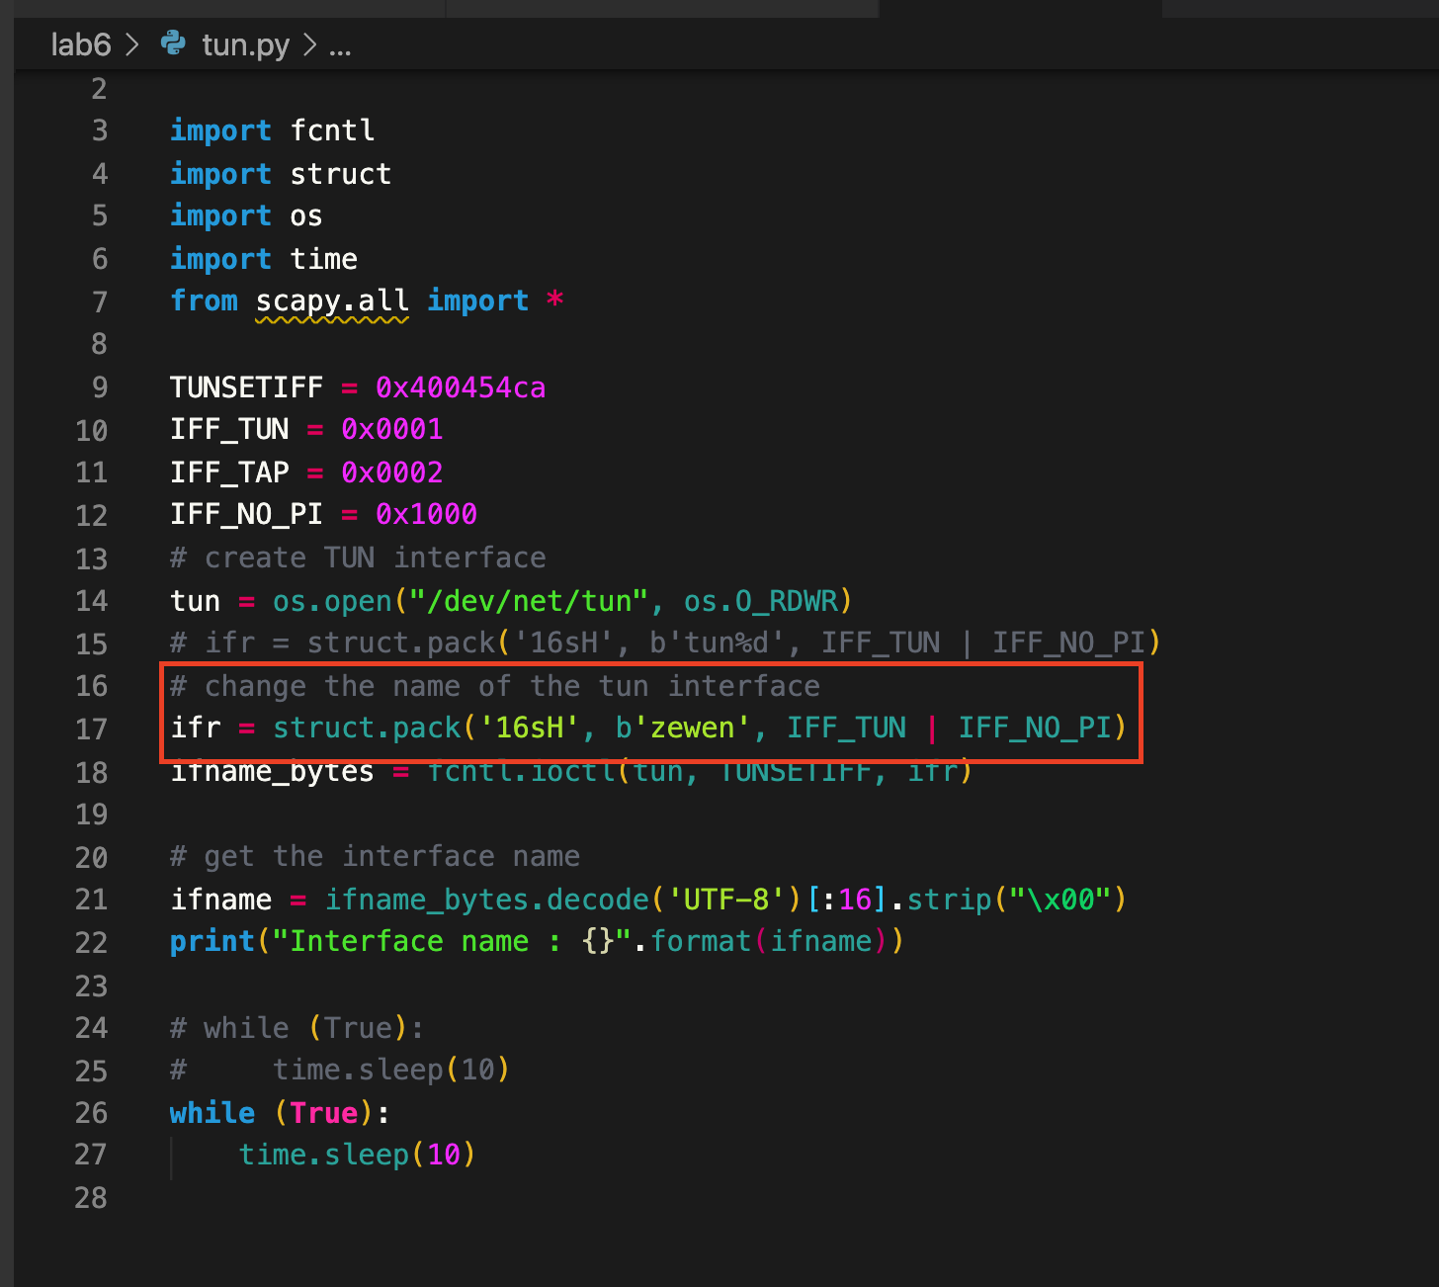

Then I run this python file by using the command “chmod a+x tun.py” and command “sudo python tun.py”.

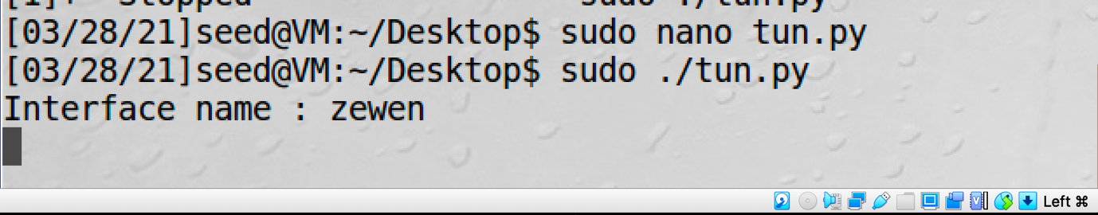

As you can see the name of the interface has become my last name.

Secondly, I run the command “ip address” on a separate terminal.

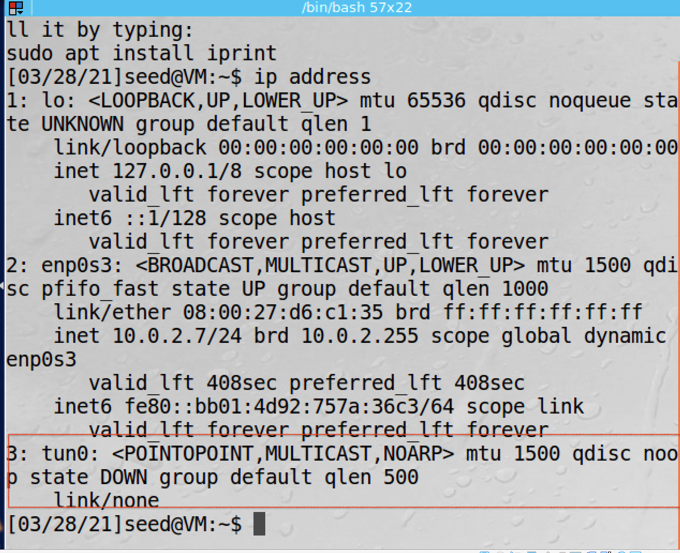

Since there is no ip address bind to this interface yet, we only can see there is a new tun0 interface.

1. Set up The TUN interface

I use the command “ sudo ip addr add 192.168.53.99/24 dev zewen” and command “ sudo ip link set dev tun0 up” to assign an IP address to the interface and bring up the interface. I also add two line of code to the tun.py, then every time I run this python file, it will automatically assign the ip address to the interface then bring it up.

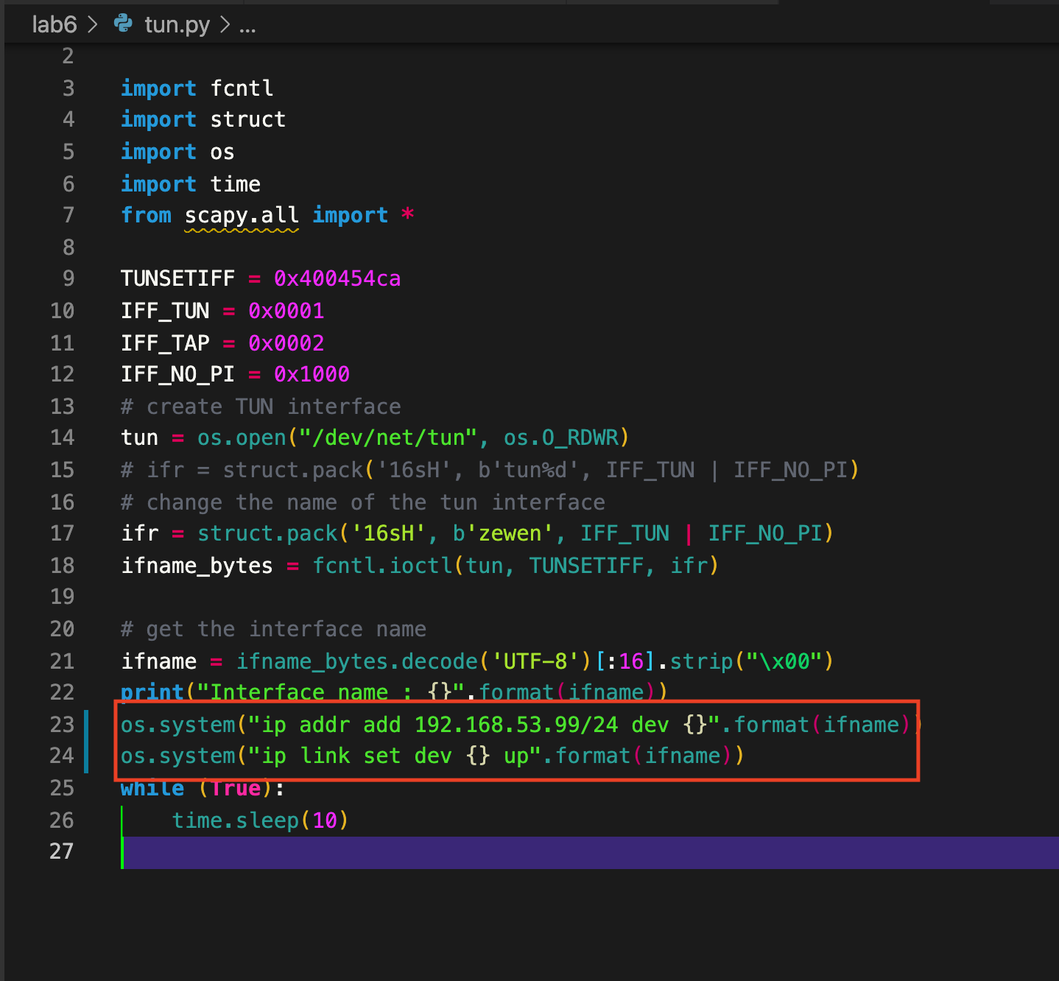

Then I run the command “ ip address” again.

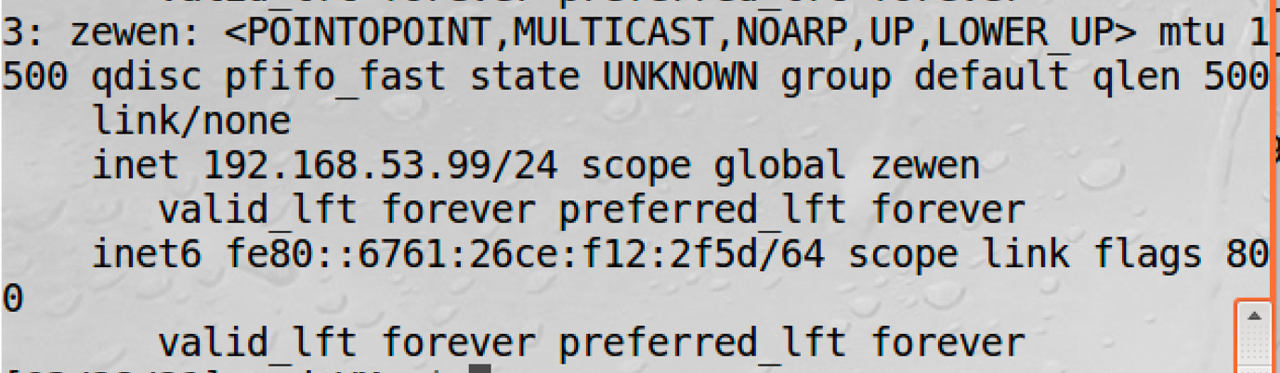

As you can see the IP address has been assigned to this interface.

1. Read from the TUN interface.

I create a tun1.py to read the traffic.

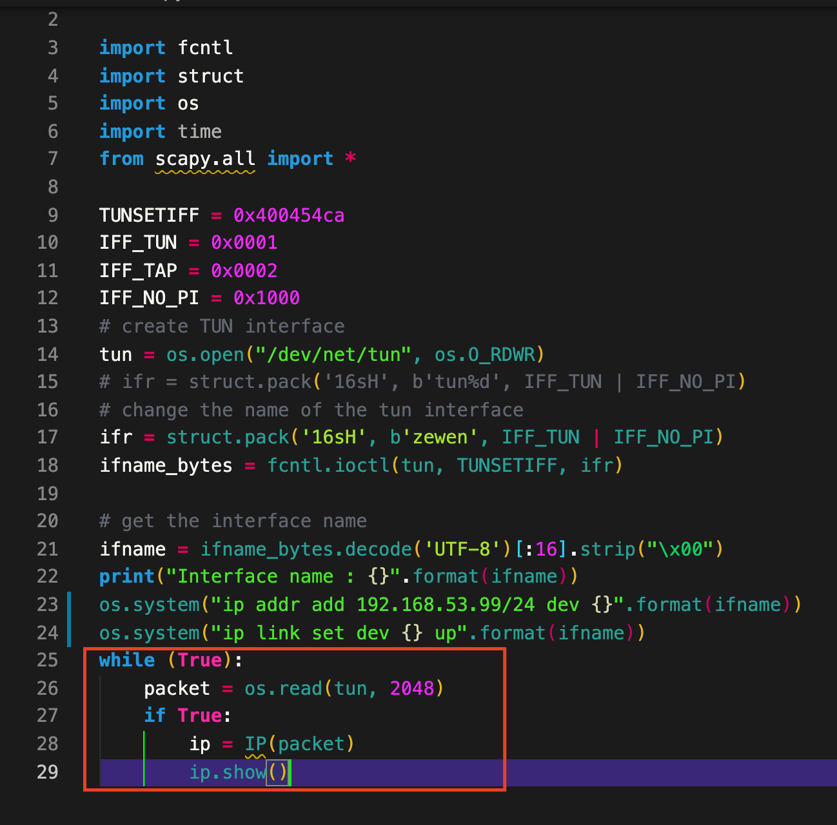

On Host U, I ping the 192.168.53.2, then the interface will show this packet information.

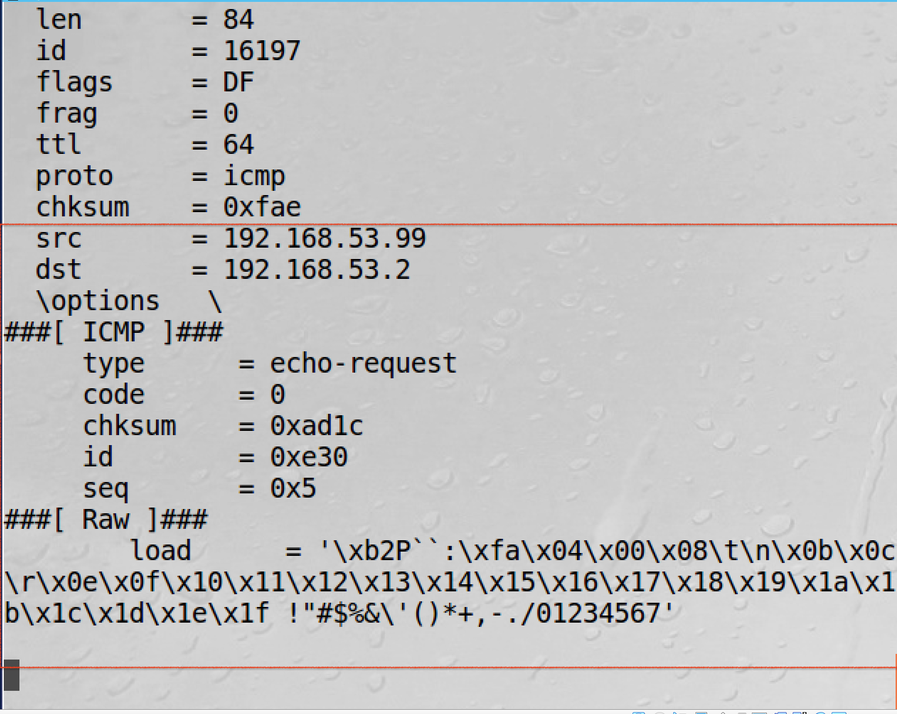

1. I create a tun2.py file by modify the original tun.py file.

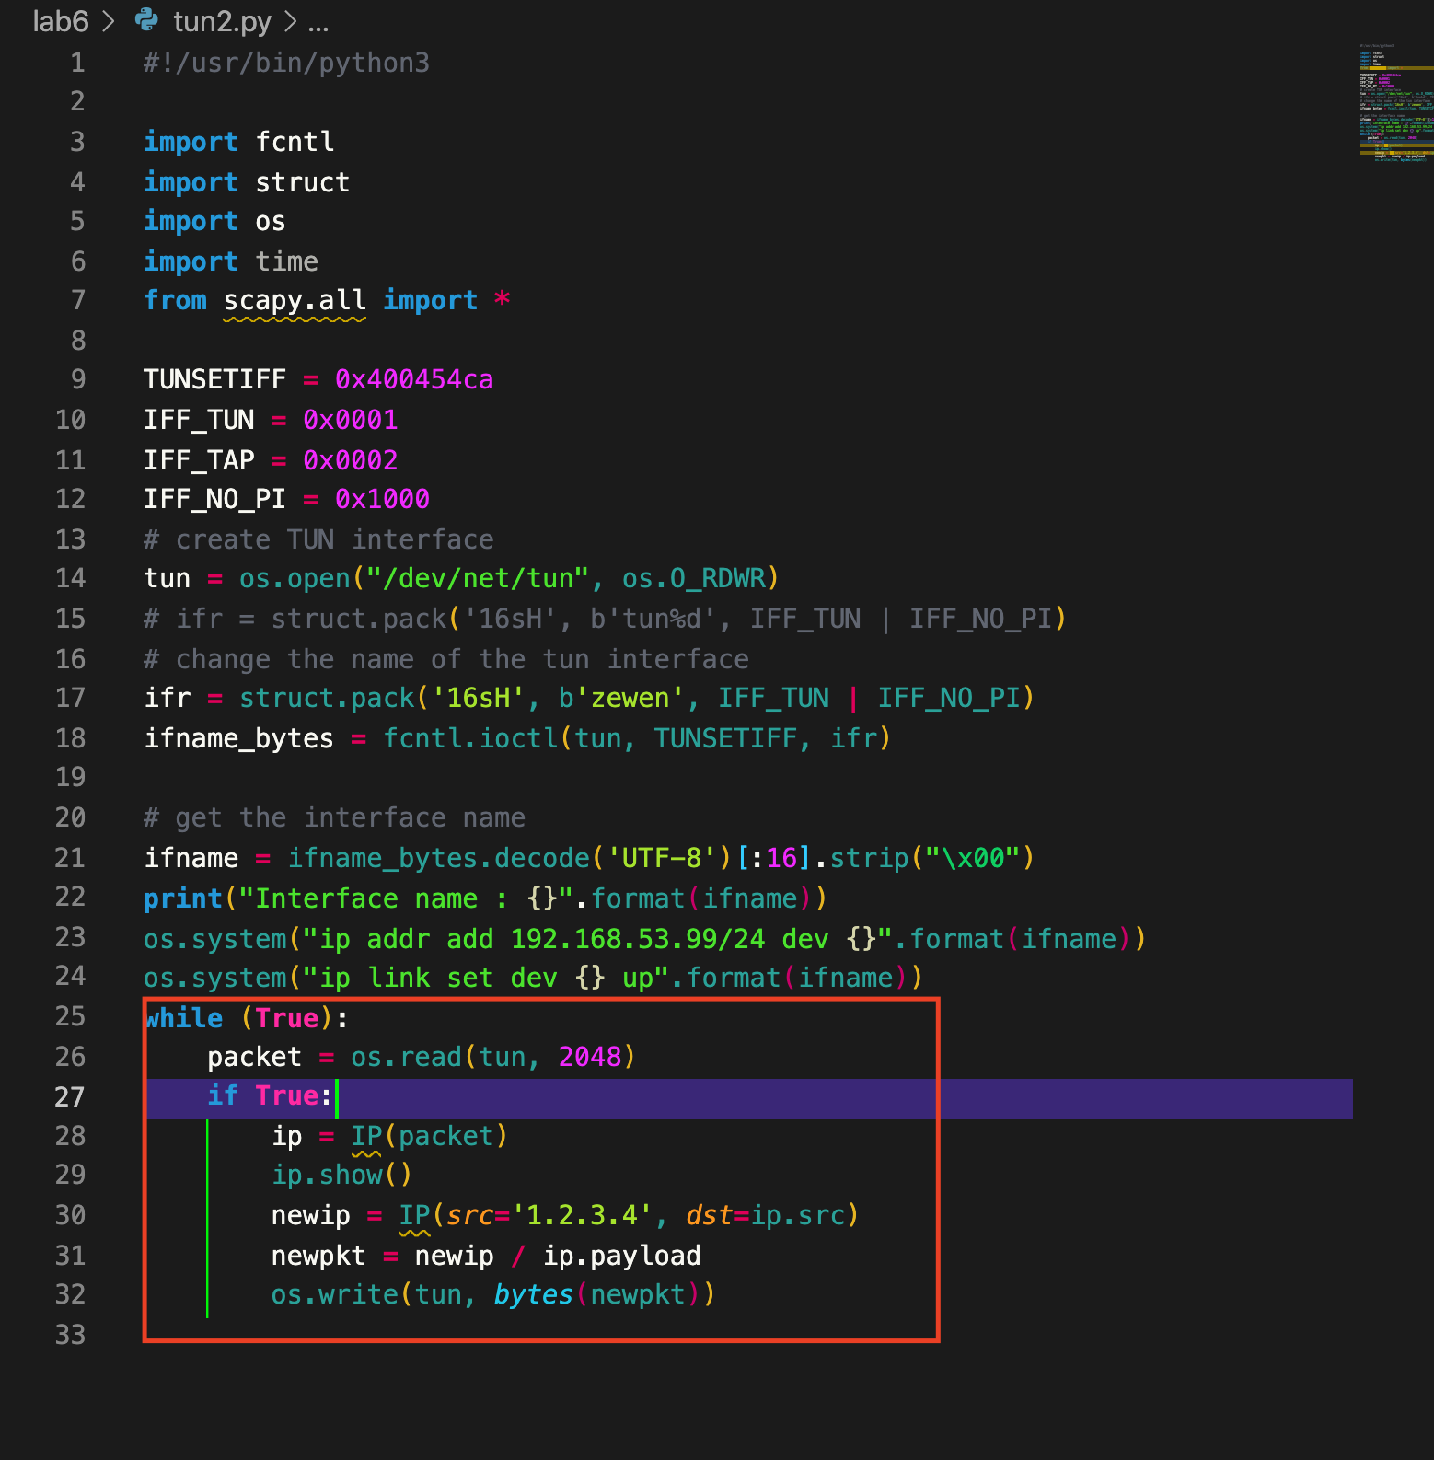

After the tun received a packet, I will modify the ip header by changing it to 1.2.3.4

Task3: Send the IP packet to VPN Server Through the tunnel

Task4: Set Up the VPN Server

Task5: Handling Traffic in Both Directions

Task6: Tunnel-Breaking Experiment